Universitas Ma’arif Nahdlatul Ulama Kebumen
URL: Https://jurnal.umnu.ac.id/index.php/KST/
Email: kridatamasaintek@gmail.com
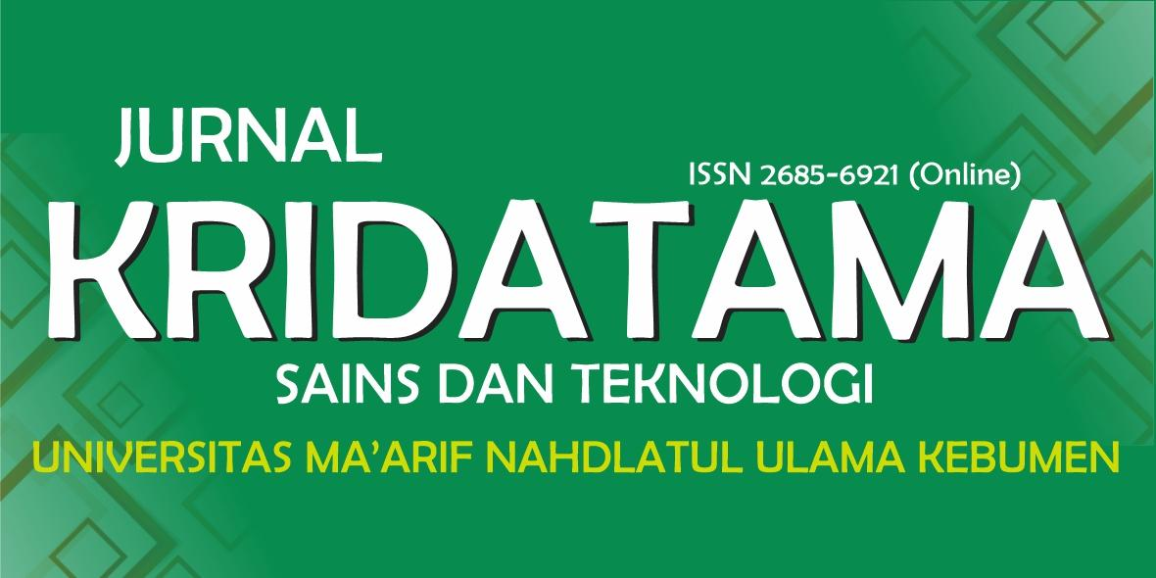
DOI Prefix: 10.53863/kst
ISSN 2685-6921 (Online)

AUTHOR DECLARATION
JURNAL KRIDATAMA SAINS DAN TEKNOLOGI
Full Name* | :
Affiliation* | :
Address* | :
E-mail* | :
Contact Person* | :
Title of the Manuscript | :

Author(s) Name:
- Name and Title
- Name and Title
- Name and Title
- Name and Title
- Etc.
As the Corresponding Author, hereby declare that:
- This manuscript is original and has never been published before. during the peer review process by this journal, the author will not withdraw and send to other journals for assessment / publication;
- I/We would like to improve the manuscript that has been assessed and not withdrawn unilaterally without informing the editors, especially if the manuscript is in the peer review process;
- I/We declare that this manuscript does not violate any party's intellectual property rights. I/We agree to indemnify and hold harmless the Jurnal Kridatama Sains dan Teknologi from any claims of infringement of intellectual property rights.
- I/We hereby confirm that all the authors have made a significant contribution to the manuscript.
I made this statement to be used properly.
__________________, ___ – ___ – ______

(*Name Author)
*) Filled with the Corresponding Author data
This statement should be uploaded for additional files when submitting your manuscript (Uploaded files are scientific articles and Author Declaration. Upload files separately)
The Corresponding Author is the sole contact for the Editorial process and is responsible for communicating with the other authors about progress, submissions of revisions and final approval of proofs.

